President’s Office.
REGIONAL ADMINISTRATION AND LOCAL GOVERNMENT AUTHORITY.
ARUSHA DISTRICT COUNCIL.
FORM FOUR PRE-MOCK EXAMINATIONS.
031 PHYSICS.
Time 3 Hours Thursday,02ndMarch 2020 a.m

Instructions:
1. This paper consists three (3) sections A, B and C.
2. Answer all questions in section A, B and any two (2) questions from section C.
3. Write your Examination number on every page of your answer sheet.
4. Mathematical tables and non programmable calculators may be used.
5. Marks for each part of question are indicated in the right-hand margin of each question.
6. The following constants may be useful:
- Coefficient of linear expansion of iron =12x.
- Coefficient of liner expansion of aluminium=24x.
- The velocity of sound wave in air =340m/s.
- The acceleration due to gravity=10m/.
- Density of water=1000Kg/.
- Speed of light in air=3m/s.

Section A (15marks).
Answer all questions in this section.
1 Choose the correct answer from the four possible answers A, B, C and D.
(i) A micrometer is used to measure the diameter of a uniform wire as show in diagram below.
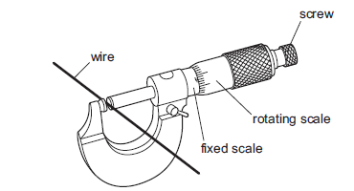
What is done to obtain the accurate answer:
- make a micrometer horizontal and then use the scales to find the reading.
- substract the fixed scale reading from the rotating scale reading.
- substract the rotating scale reading from the fixed scale reading.
- (D)use the scales to find the reading and add or substract any zero error.
(ii) A car’s acceleration and maximum speed are improved by using an engine of smaller mass and greater driving force.How many of the underlined quantities are vectors?
(A)1 (B)2 (C )3 (D)4.
(iii) The diagram below shows the distance time graph of a car.
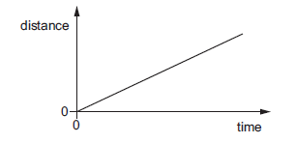
The car is travelling along a straight road up a hill.Which quantity for the car is constant and greater than zero?

- acceleration
- gravitational potential energy.
- kinetic energy.
- resultant force.

(iv) Identify the false statement:
(A) The coefficient of friction increases on increasing the area of contact.
(B) It is difficult to run on sand as the force of friction is small.
(C) Friction is necessary in everyday life.
(D) Friction cause wear and tear of moving machinery parts.

(v) A small motor has an input power rating 10W and is run for 5minutes.What is the electrical energy input to the motor in this time:
(A)2.0J (B)50J (C)300J (D)3000J.
(v) Two cylindrical vessels are joined together and filled with water as shown in Figure below:
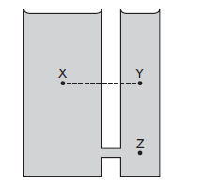
How does the pressure at point X compared to pressure at points Y and Z?

 | Compared to Y | Compared to Z
A | Pressure at X is higher | Pressure at X is lower
B | Pressure at X is higher | Pressure at X is the same
C | Pressure at X is the same | Pressure at X is lower
D | Pressure at Xis the same | Pressure at X is the same

(vii) A fixed mass of a gas undergoes a change of volume at constant temperature.Which graph show the relationship between the volume and pressure of the gas?
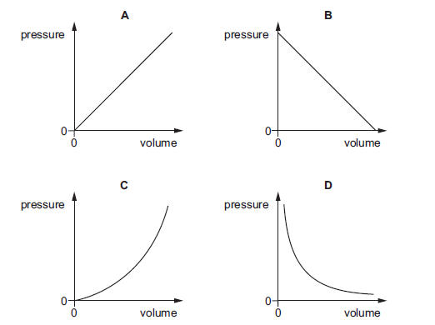
(viii) If 120Volts are used to light a 30W bulb, what will be the current flowing through a bulb?
(A)40A (B)30A (C)0.25A (D)4A

(ix) The mercury in glass thermometer shown below has a linear scale.At a temperature of 100, h has a value of 28cm,at 80, h has a value of 24cm.What is the value of h when the temperature is at 0.
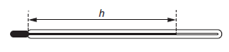
(A)0.0cm (B)2.8cm (C )4.0cm (D)8.0cm.
(x) A certan simple pendulum has a period of 2seconds.What will be the period of pendulum when the length of pendulum is doubled?
(A)4seconds (B)2.82 sconds (C)8seconds (D)3.2 seconds.

2.Match the items in list A with responses in list B by writing the letter of correct response besides the item number in your answer sheet.
List A | List B
(i)Fission | (A)Produce small nuclei and is the energy source of a star.
(ii)Fusion | (B)Produce small nuclei and release energy in power station.
(iii)Ability of liquid to rise or fall in a narrow tube. | (C)Capillarity
(iv)Force which resists a fluid to flow | (D)Produce larger nuclei and release energy in power station
(v)Ability of the surface of a liquid to behave like a fully stretched elastic skin. | (E)Osmosis
 | (F)Viscosity
 | (G)Cohesive
 | (H)Surface Tension
 | (I)Adhesive.

Section B (60marks).
Answer all questions in this section.
3(a) A luggage of mass 18kg is being loaded by a conveyor belt as shown in Figure below.
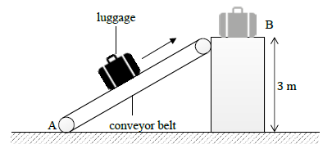
(i) Calculate the gravitational potential energy of the lagguage if it is raised through a height of 3m(02marks).
(ii) Calculate the power needed to raise the luggage to a height of 12m in 12 seconds(02marks).
(iii) The conveyor belt is removed .The luggage is accidently dropped from point B.Calculate the velocity with which the luggage will hit the ground(02marks).

3 (b) A lever can be used to move a large load by exerting a smaller force as shown in Figure below.Such a uniform lever of weight 10N is used to move a load of 500N.
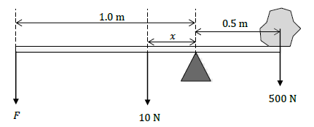
- What is the total length of the lever(01mark)
- What is the length x shown in Figure above(01mark).
- Calculate the size of the smallest value of F needed to move the load(02marks).

4 (a) A 20 resistor and a 60Ω resistor are connected to a 30V source as shown in Figure below.
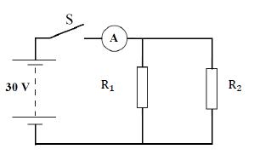
- How are the resistors and resistor connected(01mark).
- Calculate the total resistance of the circuit when the switch is closed(02marks).
- Calculate the current shown by the ammeter Awhen the switch S is closed(02marks).
4(b) A certain type of recharchable battery is capable of delivering a current of 0.2A for
- seconds before it needs to be recharged.Calculate:
- the total charge the battery can deliver before it needs to be recharged(02 marks).
- the maximum time it could use without being recharged,if the current through it were 0.5A(02 marks).

5(a) Light is a part of the electromagnetic spectrum.Name the part of electromagnetic spectrum which is responsible for:
- Skin tanning(01mark).
- TV remote control(01mark).
- treatment of cancer patients(01mark).
- Cooking food(01mark).

5(b) Name two common properties of electromagnetic waves(02marks).

5(c) A vibrating tuning fork is placed close to a microphone as shown in Figure below.
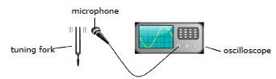
- Are sound waves transverse or longitudinal?(01mark).
- Explain in terms of movement of air particles,how sound reaches the microphone(01mark).
- The speed of sound in air is 340m/s.Given the wavelength of waves is 170cm.Calculate the frequency of sound produced(02marks).

6(a) An electric plug is shown in Figure below.
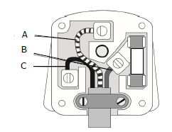
- State the name of wires labelled A,B and C(03marks).
- Name two safety features present in the plug(02marks).

6(b) A student uses this plug with an electric heater rated 2.6Kw.Given that the voltage supplied is 230V.Calculate the current flowing through this heater(02marks).

6(c) Suggest a suitable value for the fuse in the plug(01mark).

6(d) Calculate the cost of using this heater for 8hours if the electricity costs 17cents per Kwh(02marks).

7(a) A student hangs an iron block to a stand and clamp as shown in Figure (a) and (b) below:
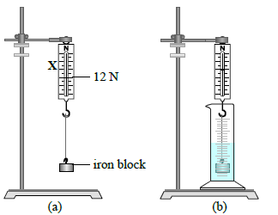
  - Name the apparatus X that is used to measure the weight of iron block(01mark).
  - Draw and label the forces acting on an iron block(02marks).
  - The student lowers the iron block in a measuring cylinder as in Figure (b).The liquid in the measuring cylinder rises from 50 to 203.
- Calculate the volume of the iron block(02marks).
- The weight of the iron block is 12N.Calculate its mass in grams(02marks).
- Determine the density of iron block(03marks).
8(a) Explain why a tightly closed metal lid of a glass bottle can be opened more easily if it is put in hot water for sometimes(04marks)
8(b) An iron rod of length 50cm is joined at an end to an aluminium rod of length 100cm.All measurements done at 20.Find the length of composite system at 100 and its average coefficient of linear expansion(06marks).

Section C(25 Marks).
Answer two(2) questions from this section.
9(a) Figure below shows the parts of an X-ray tube.
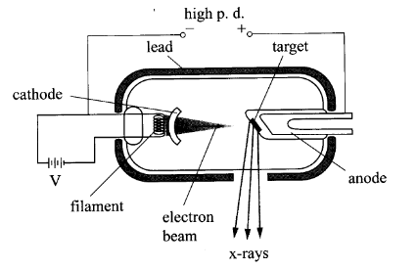
- Explain why a potential difference is applied to the filament(02marks).
- Explain why a high potential difference is applied between the cathode and the anode(02marks).
- Explain why most of the tube is surrounded by lead(02marks).
9(b) Explain how the penetrating power of X-rays produced is related to applied potential difference(04marks).
9(c) Explain briefly the difference between soft X-rays and hard X-rays(02 marks).

10 A radiation detector is connected to a counter and used to investigate a radioactive stone.The stone is wrapped in various materials and different readings are recorded in counts per minutes as shown in Figure below:
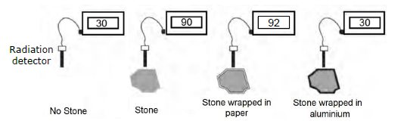
- Give the name of a suitable radioactive detector(01mark).
- What causes the reading of 30 counts per minutes when no stone is present?(01mark).
- Calculate the corrected count rate in counts per minute of the stone when it has no wrapping(01mark).
- State the type or types of radiation that this stone is emitting.Explain your reasoning(03marks).
- The rock now is placed in a thick lead container.Suggest the value of the count rate you would expect in this case(02marks).
- The half life of this radioactive stone is 2days.Estimate the corrected count rate obtained from the stone after 4days(03marks).
- Give two reasons why this stone should not be used in smoke detector(01marks).

11(a)The earth is the third planet from the sun.
- Name the two planets closet to the earth’s orbit(02marks).
- What force which keeps planets in orbit around the sun(01mark).

11(b) A space probe takes approximately 90days to reach Mars when travelling at 8000m/s.Calculate the distance travelled by the rocket(04marks).

11(c) Explain the following methods as used in the magnetizatization of magnetic materials:
- Double touch method(02marks).
(ii) Divided double touch method(02marks).

